
COMMUNITY-POWERED MATERNAL & NEWBORN HEALTH
How it works
Give/Start a JoyFund
Your Joy Saves Lives
JoyFund mobilises local philanthropy to help vulnerable pregnant women overcome financial and last-mile barriers to essential maternal and newborn care—from pregnancy through the first 42 days after birth.
Start a JoyFund
Support a mother
Impact
About
Resources
Get Support
Home
Logo Remains

HOW JOYFUND WORKS
- Mobilize Local Giving  Help low-income pregnant women overcome verified financial barriers to essential maternal and newborn care. | 2. Identify Need  Help low-income pregnant women overcome verified financial barriers to essential maternal and newborn care. | 3. Enable Access  Support transportation to participating health facilities and referral hospitals when distance and cost stand in the way of care.
4. Continue Care  Help eligible women stay connected to essential care from pregnancy through childbirth and the first 42 days after birth. | 5. Verify & Pay  Eligible healthcare costs are verified with participating health facilities, with payments made directly to providers where applicable. | 6. Power Local Solutions  Help demonstrate that Cameroonian communities can mobilise their own resources to improve maternal and newborn health

WHY JOYFUND?
Built on Local Philanthropy  JoyFund transforms everyday giving and moments of celebration into organised support for vulnerable mothers and newborns. | Verified Support  Women seeking support are screened against defined eligibility criteria, with healthcare needs verified through participating health facilities. | Direct-to-Provider Payments  Where healthcare costs are supported, funds are paid directly to participating providers rather than handed to beneficiaries.
Transparent & Traceable  Contributions, approved support and payments are digitally documented to strengthen accountability from giving to care. | Designed Around Access  JoyFund addresses not only healthcare costs, but verified last-mile barriers such as transportation to care and referral facilities. | Complements Existing Systems  JoyFund targets verified gaps that can remain even where public maternal and newborn health programmes already exist.

Get Support

Every Mother
Deserves a
Safer Beginning
JoyFund is not an emergency medical service. If you are experiencing urgent pregnancy-related symptoms or have been advised to seek immediate medical attention, please go to the nearest appropriate health facility without waiting for JoyFund approval.
Referral Support
Transport to a referral hospital when higher-level care is required.
Transport Support
Transportation to participating health facilities for scheduled care.
Care Support
Eligible antenatal, maternal and newborn healthcare costs.
Application is confidential.
Support is subject to eligibility, verification
and available resources.
APPLY FOR SUPPORT
Are you pregnant and having difficulty paying for or reaching essential maternal healthcare?
JoyFund may be able to support your care journey from pregnancy through childbirth and the first 42 days after birth.

G

Need Help
Call or WhatsApp us at
681065173
We're here to walk this journey with you.
Your application is confidential. Our team will treat you with dignity and respect every step of the way.
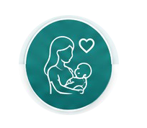
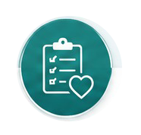


What Happens Next
Apply
Complete the short
Get Support form.
It takes just a few
Minutes

We Review
JoyFund checks basic eligibility and may contact you for more information.
We Verify
A social worker or participating health facility confirms your care and access needs.
Support
Is Planned
Where eligible, JoyFund identifies what existing programmes already cover and what verified gap remains.

Care & Follow-up
Approved support is linked to participating health facilities, transport or referral needs, with follow-up through Day 42.
Minutes


We've made the process simple, respectful and transparent. Here's what you can expect after you submit your application.

1. Who can apply for JoyFund support?
JoyFund primarily supports low-income and vulnerable pregnant women who face financial or access barriers to essential maternal healthcare. Support is intended to accompany eligible women from pregnancy through childbirth and the first 42 days after birth.
Applying does not automatically guarantee support. Each application is reviewed and verified based on eligibility, identified needs, existing health coverage and available JoyFund resources.

2. What kind of support can JoyFund provide?
Depending on your verified needs and what is already covered by existing health programmes, JoyFund may support eligible maternal and newborn healthcare services, transportation to participating health facilities, and referral transportation when higher-level care is required.
The exact support provided will be determined after your application and healthcare needs have been verified.

3. Do I have to pay to apply?
No. Applying for JoyFund support is free.
You should not pay anyone to submit an application, have your application reviewed or be selected for support.

4. Does submitting an application mean I will automatically receive support?
No. Submission of an application is a request for assessment, not a guarantee of financial support.
JoyFund will review your application, verify your circumstances and determine whether you meet the programme's eligibility criteria. Support will also depend on the type of need identified, existing coverage and available programme resources.
Everything you need to know before applying for JoyFund support.
Frequently Asked Questions

5. What happens after I apply?
JoyFund will first review your application. If necessary, we will contact you for additional information. Where you meet the initial eligibility requirements, a designated JoyFund team member, social worker or participating health facility may help verify your maternal healthcare and access needs. JoyFund will then determine what support may be appropriate and communicate the next steps to you.

6. What if I am already enrolled in Universal Health Coverage or another health programme?
You can still apply. JoyFund is designed to complement rather than duplicate existing health programmes. During verification, we will identify what is already covered and determine whether important financial, transportation, referral or other eligible access barriers remain. Where another programme already covers a particular service, JoyFund will generally not pay for the same service again.

7. Will JoyFund give the money directly to me?
Generally, no. Where JoyFund pays for healthcare services, payments should ordinarily be made through participating health facilities or approved service arrangements, rather than giving cash directly to beneficiaries. Transport and referral support will similarly follow JoyFund's approved procedures. This approach helps ensure that funds raised by the community are used for the verified purpose and can be properly accounted for.

8. How long can JoyFund support me?
For eligible women, JoyFund's maternal and newborn support pathway extends from pregnancy through childbirth and the first 42 days after birth. The first 42 days after childbirth are a particularly important period for the health and wellbeing of both mother and newborn. This does not mean that every beneficiary receives every available service throughout the entire period. Support is based on verified individual needs and the approved JoyFund package.

9. Will my personal and health information be kept private?
Yes. Information submitted through the Get Support application is collected for purposes such as assessing eligibility, verifying needs, coordinating approved support, monitoring programme delivery and improving JoyFund. Access to personally identifiable and health information should be restricted to authorised persons involved in these functions. JoyFund may use anonymised and aggregated information to understand maternal-health barriers, improve programming and contribute to research, advocacy and policy dialogue. Such reporting should not identify individual women.

10. Can someone help me apply if I cannot complete the online form myself?
Yes. We do not want lack of internet access, digital skills or literacy to prevent an eligible woman from seeking support. Where available, a family member, authorised community worker, social worker, participating health facility or JoyFund representative may assist you to complete the application with your knowledge and consent.

 | Ab ABOUT US
 | 01 OUR STORY
 | 02 2. WHY JOYFUND MATTERS
 | 03 WHY WE EVOLVED
 | 04 04 OUR PHILOSOPHY — FROM RESEARCH TO PRACTICE
 | 05 OUR APPROACH
 | 06 WHO WE ARE
 | Our Vision
 | 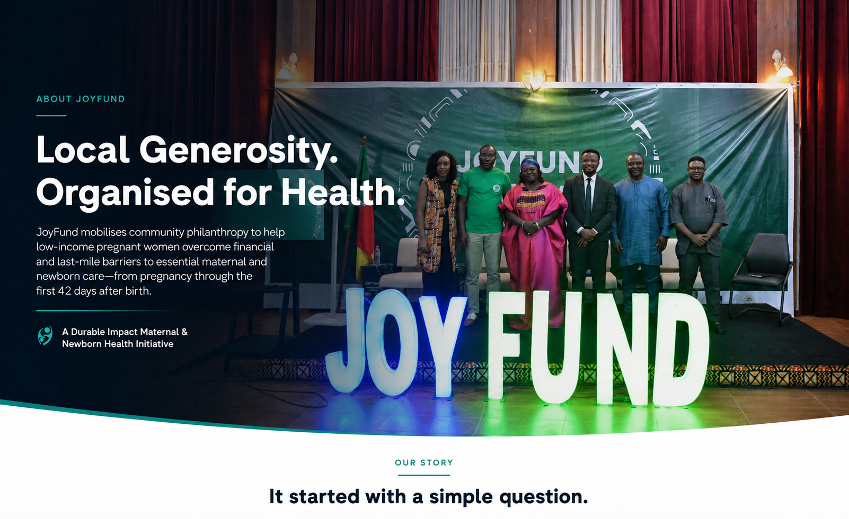
Our Story
 |  |  | It Started With One Woman and a Question of Trust. JoyFund's story began before there was a platform, a website or even a name. In early 2021, our founder, Dr. Eric Kepeh Moh, came across the story of a pregnant woman named Jane who urgently needed support for her delivery and hospital care. A public appeal had already been made on her behalf, asking people to contribute whatever they could.  After verifying her situation, Eric contributed and shared the appeal with friends, family, mentors and professional networks. People responded. They wanted to help. But almost everyone asked some version of the same questions: Is the story real? Can we trust that the money will reach her? Those questions revealed something important.  The problem was not simply a lack of generosity. It was also a question of trust. Rather than transferring the contributions through an intermediary, Eric travelled to Douala, met Jane and personally delivered the money that had been mobilised. She received the support she needed, but the experience left behind a question that would eventually become much bigger than one medical appeal: How could we make it easier for people who want to help to do so through a mechanism they can trust? The generosity was already there. That experience reflected something deeply familiar about Cameroon.  Every day, people mobilise resources for one another through families, njangi groups, alumni associations, churches, professional networks, community organisations, diaspora networks and friendships. We contribute when someone is sick. We support one another in moments of hardship. And we come together to give during birthdays, weddings, graduations, promotions, anniversaries and other important moments in our lives.  The question, therefore, was not simply: “How do we convince people to give?” It became: “How do we organise the generosity that already exists?”  Over the years that followed, that question was explored through both practice and research into local philanthropy, community giving and locally led development. Then, with the creation of Durable Impact, came an opportunity to turn the idea into something practical: Could technology help organise our existing culture of solidarity into a more transparent, accountable and trusted mechanism for healthcare? That question became JoyFund.  JoyFund was developed as a home-grown digital platform connecting celebration, community generosity and healthcare support. The original model invited people to transform moments of joy—birthdays, weddings, graduations, promotions, anniversaries and other celebrations—into opportunities to support vulnerable people facing healthcare costs.  At its launch in June 2026, JoyFund sought to mobilise individual and community philanthropy for vulnerable mothers facing medical bills, elderly people unable to settle hospital costs, and individuals confronting critical medical emergencies. But beneath those different forms of support was one consistent ambition: To prove that local philanthropy can work in Cameroon. Not by replacing government. Not by replacing health facilities or development partners. And not by replacing the informal solidarity that already exists within our communities. JoyFund was created to organise that solidarity—to make generosity more intentional, transparent, accountable and connected to real healthcare needs. And as we began that journey, listened more closely and examined the evidence, we discovered that there was another question we needed to confront: What if we could organise that generosity earlier—before financial hardship becomes a health crisis? That question marks the next chapter in the JoyFund story.

02 — WHY JOYFUND MATTERS

The numbers tell an important story
Pregnancy and childbirth should not become more dangerous because a woman cannot afford care, reach a health facility, complete a referral or remain connected to essential maternal health services.

Yet maternal and newborn health indicators in Cameroon continue to show significant gaps in access and continuity of care. For low-income households, these challenges exist within a health system where families still carry a substantial share of healthcare costs directly.
For too many women,
pregnancy still comes with Financial barriers to essential care

THE CHALLENGE IS NOT ONLY WHETHER MATERNAL HEALTHCARE EXISTS.
It is whether every woman can reach it, afford the costs she faces, and remain connected to appropriate care when she needs it.
24 neonatal death/1,000
14 stillbirths/1,000
THE CONSEQUENCES EXTEND TO NEWBORNS
31.8%
No antenatal Care

Sources (Q3 2025 RMNCAH reporting)

232
Maternal deaths per
100,000 births

Sources (Q3 2025 RMNCAH reporting)

55%
Skilled facility birth attendance

Sources (Q3 2025 RMNCAH reporting)

72%
Health spending paid directly out of pocket

Sources (National Health Accounts / WHO)

WHY WE EVOLVED
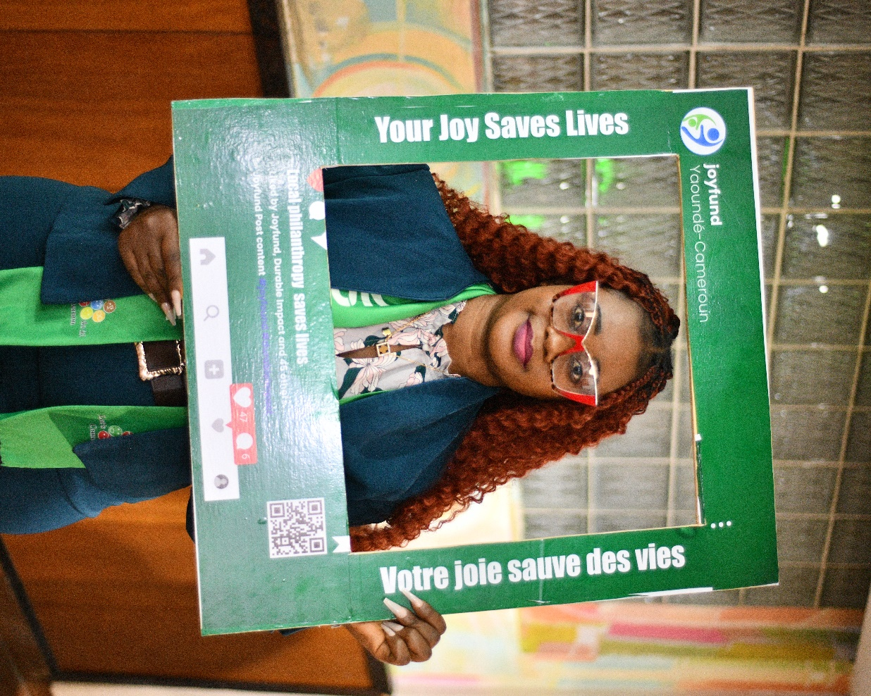 | From Responding to Medical Debt to Removing Barriers Earlier  JoyFund was originally designed to mobilise community philanthropy to help vulnerable people facing healthcare costs—including mothers with hospital bills, elderly people unable to settle their medical bills, and individuals experiencing critical medical emergencies.  That work responds to a real need.  But as we continued to learn, review evidence and better understand the realities of healthcare financing and maternal and newborn health in Cameroon, an important lesson became increasingly clear:  Waiting until someone is already in medical debt can mean intervening too late.  For a low-income pregnant woman, financial hardship may begin long before a hospital bill is issued. It may begin with an antenatal consultation she postpones because she cannot afford the associated costs. An essential test she cannot pay for. Transport she cannot afford to reach a health facility. Or a referral she cannot complete when higher-level care is needed.  By the time a family begins desperately raising money, financial and access barriers may already have delayed essential care.  So we decided to intervene earlier.  JoyFund is moving from primarily responding to the financial consequences of healthcare exclusion towards helping prevent verified financial and last-mile barriers from disrupting essential maternal and newborn care.  Our primary focus is now low-income and vulnerable pregnant women and their newborns—from pregnancy through childbirth and the first 42 days after birth.
HOW JOYFUND IS EVOLVING
THEN |  | NOW
Responding to medical debt |  | Intervening earlier
Emergency medical appeals |  | Organised health solidarity
One-off healthcare support |  | Continuity of maternal & newborn care
Waiting until financial hardship becomes a crisis |  | Addressing verified barriers before they disrupt care

The principle has not changed. The point of intervention has.
JoyFund still believes in the power of local philanthropy. We are now seeking to organise that generosity earlier
—before financial hardship becomes a health crisis.

Read Our Full Evolution Statement (This would be link to resources Menu)

